1.Host a Ubuntu Virtual Machine using Oracle VM Virtual Box. (5 marks)

<https://www.virtualbox.org/> download the virtual box

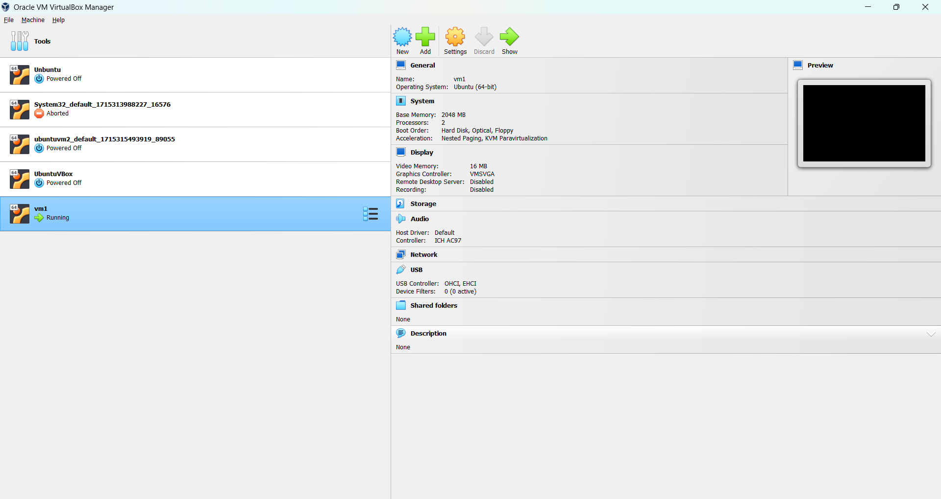

I have used image ubuntu-22.04.4-desktop-amd64

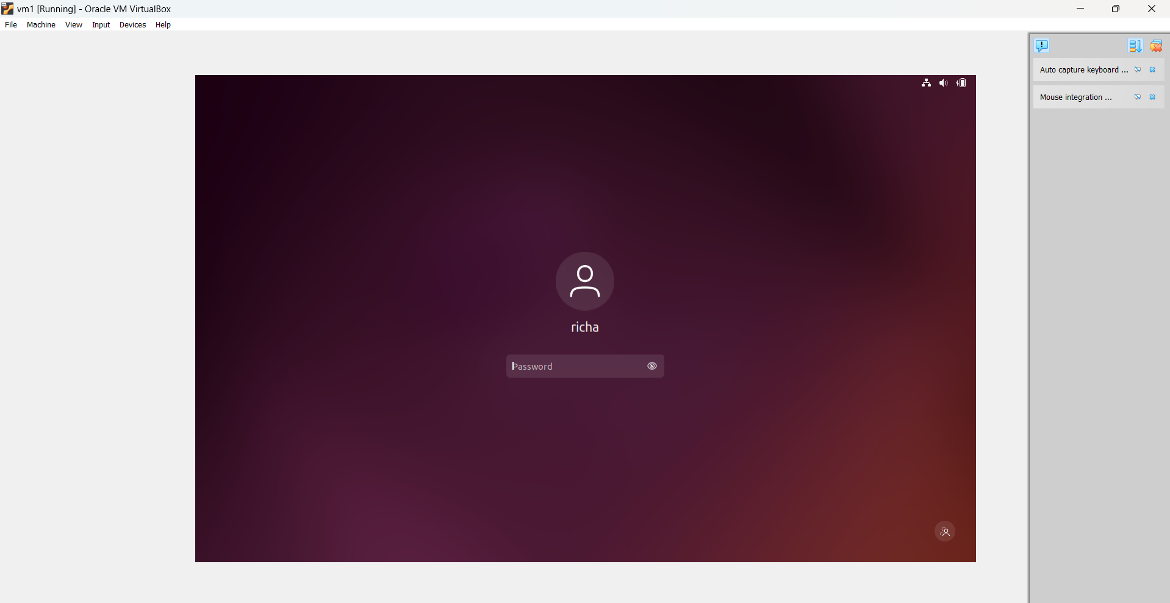

2.Set up Visual Studio code on Ubuntu VM. (5 marks)

Download from <https://code.visualstudio.com/download>

sudo apt install ./<file>.deb

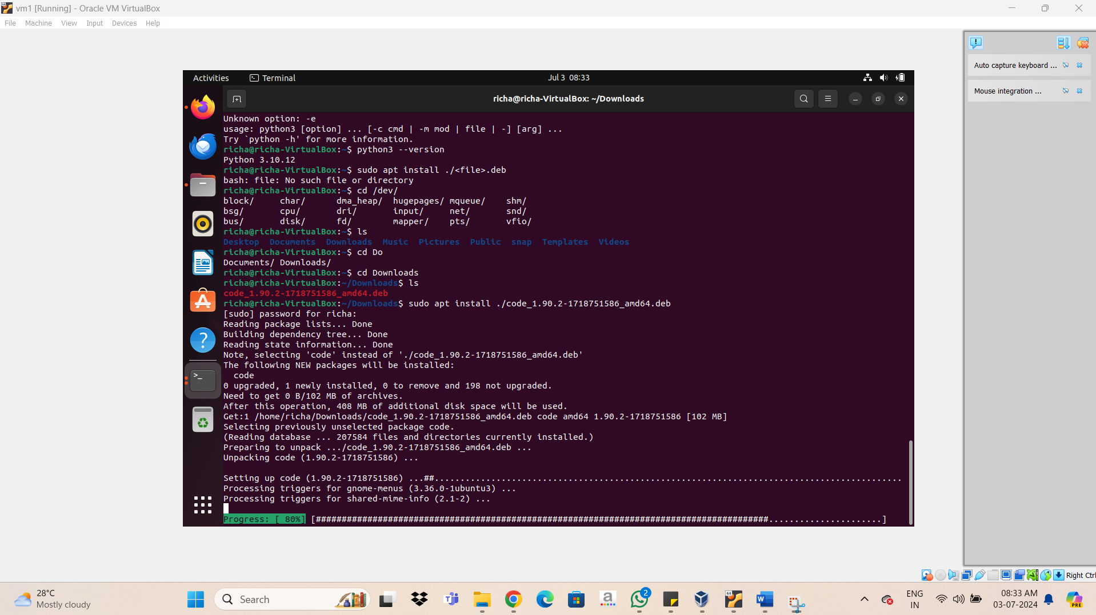

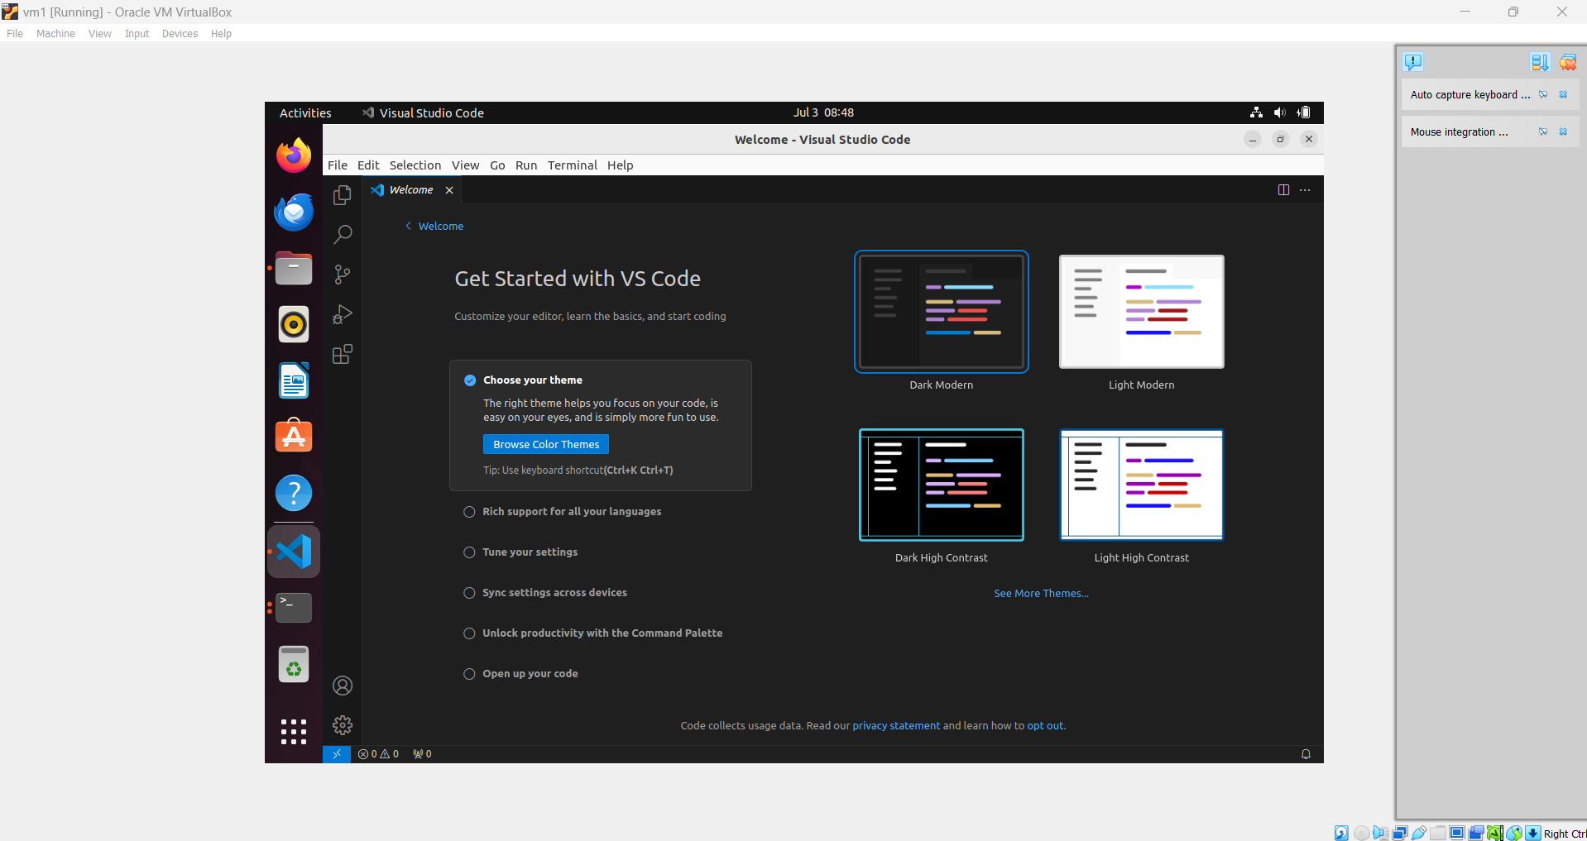

3.Set up Python. (5 marks)

Command 1: sudo apt update

Command 2: sudo apt install software-properties-common

Command 3: sudo add-apt-repository ppa:deadsnakes/ppa

Command 4: sudo apt install python3.9

On ubuntu

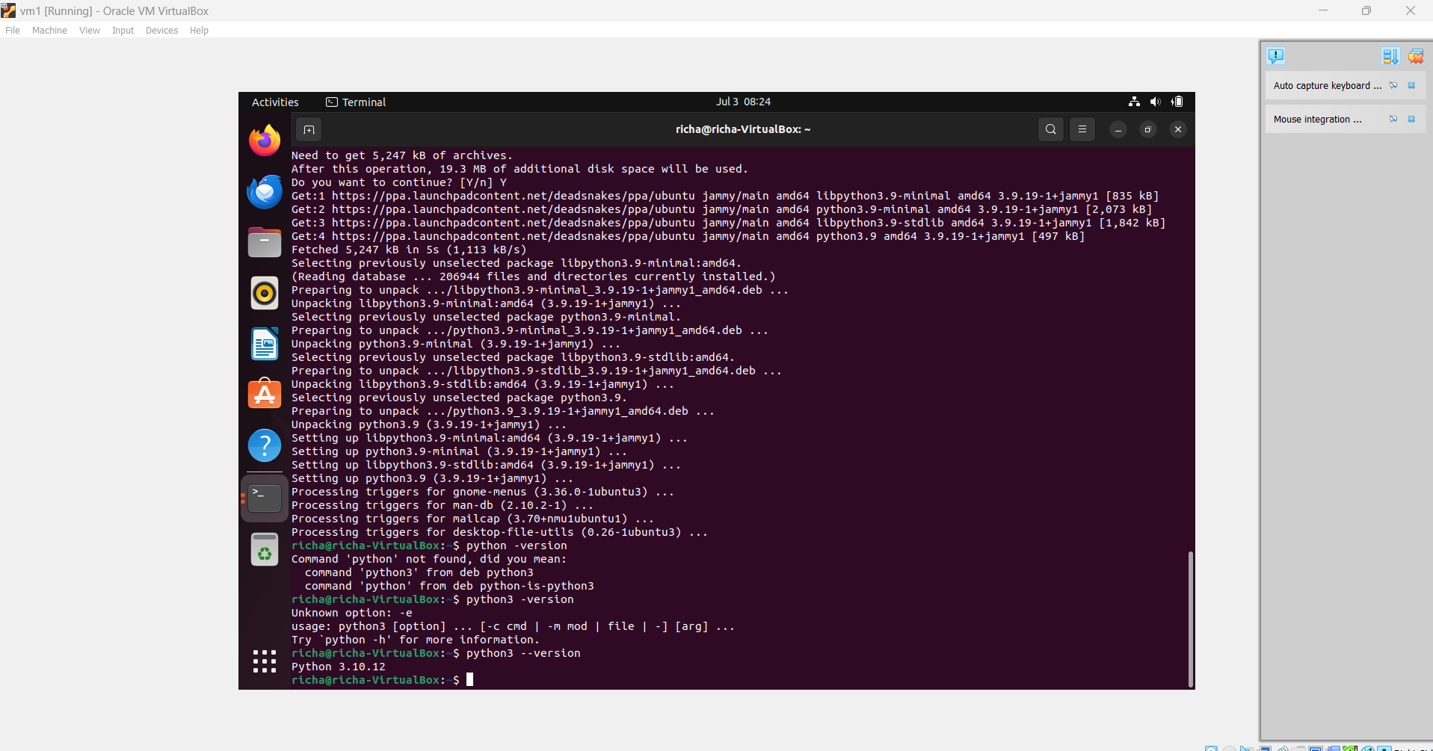

On vscode

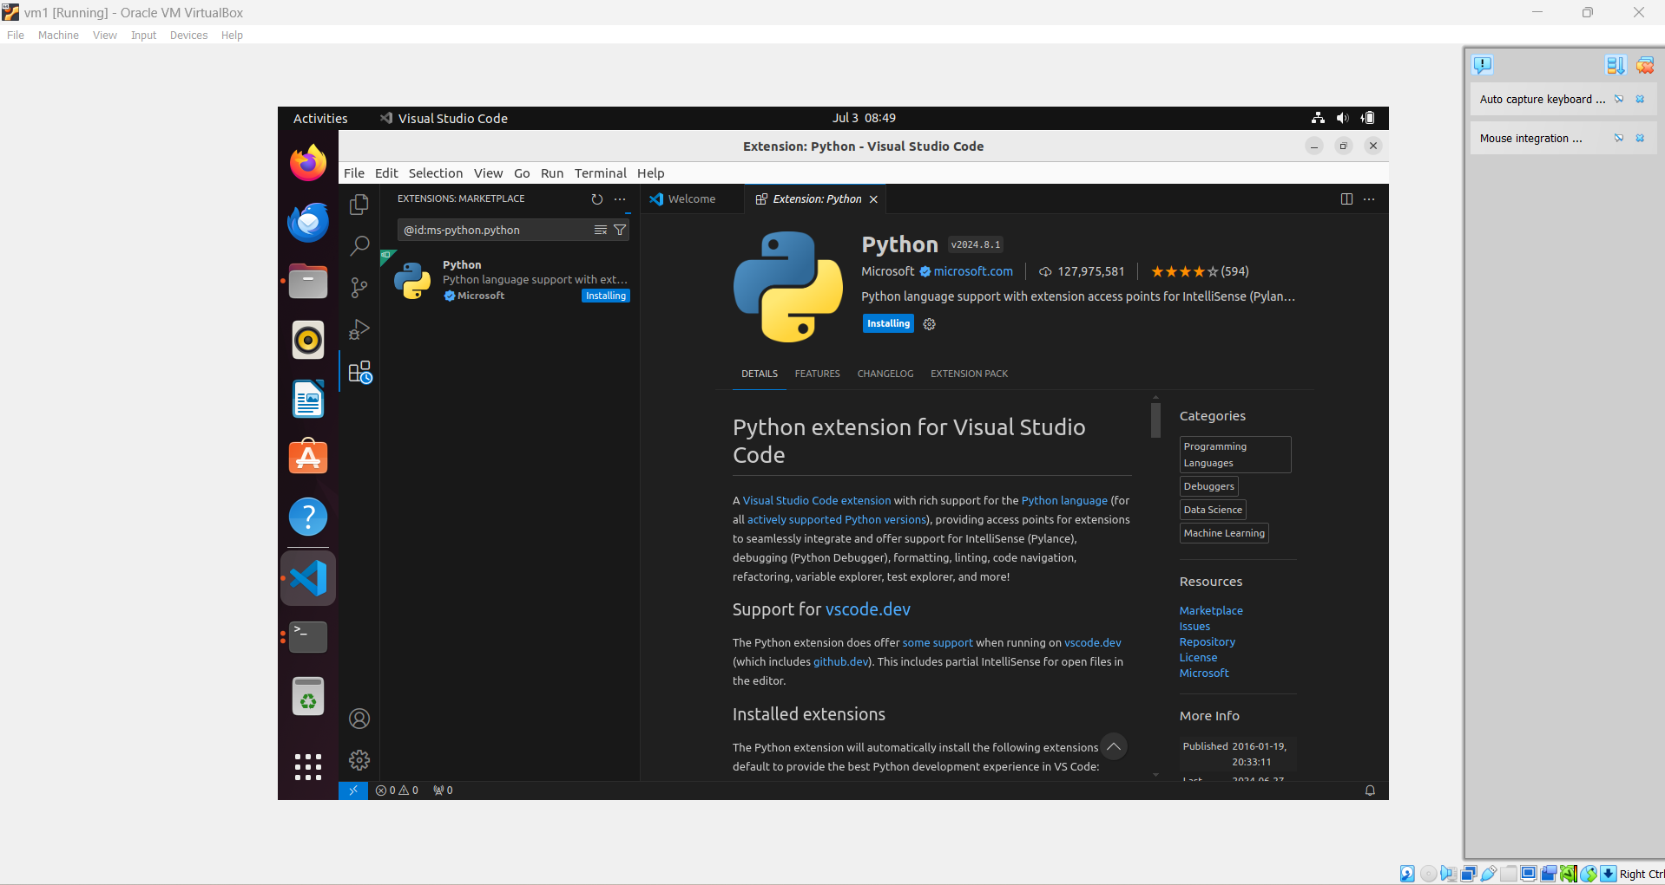

4.Clone this Github repository https://github.com/Vikas098766/Microservices.git(1 mark)

apt-get install git

add-apt-repository ppa:git-core/ppa

apt-update

apt install git

I have cloned it in Vs code

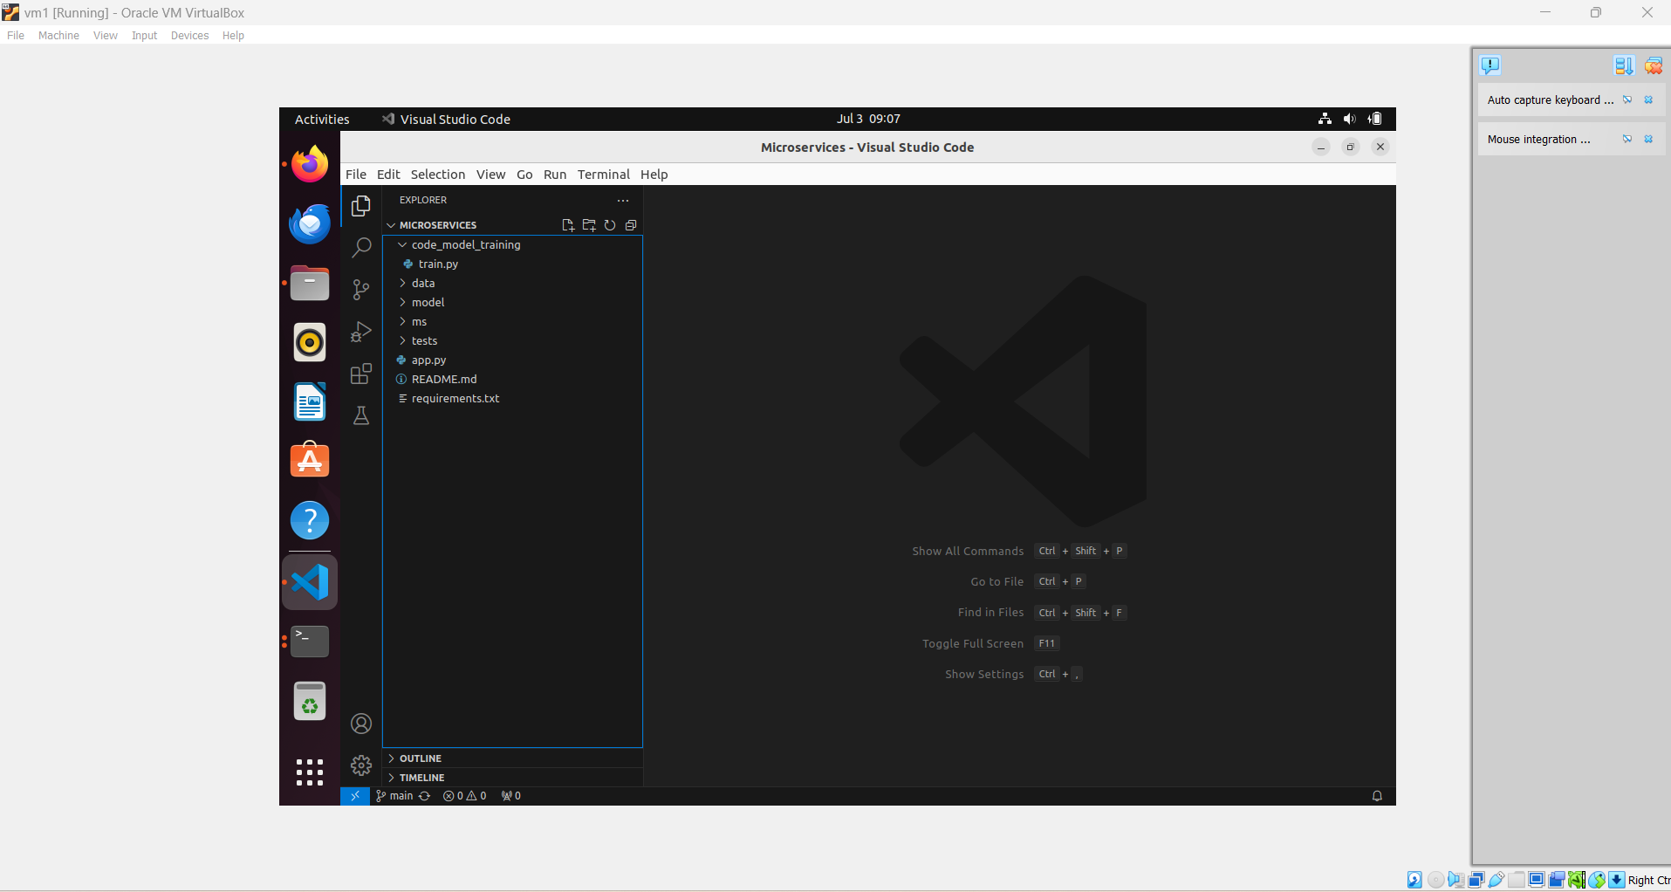

5.Create a Virtual Environment. (1 mark)

Commands:-

apt install python3.10-venv

python3 -m venv venv

source venv/bin/activate

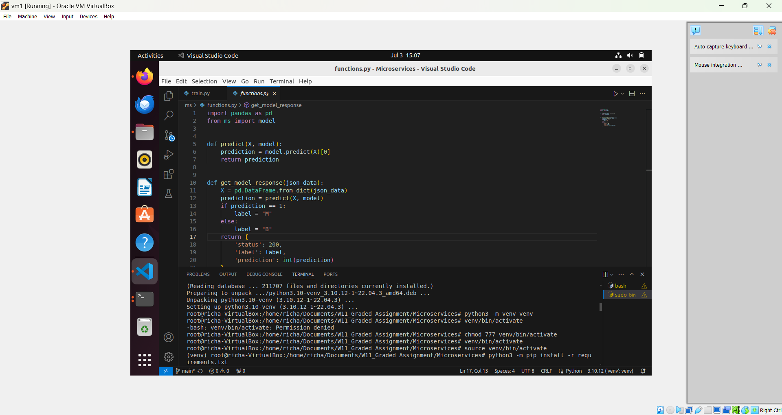

6.Install the dependencies from requirements.txt file. ( 1 mark)

python3 -m pip install -r requirements.txt

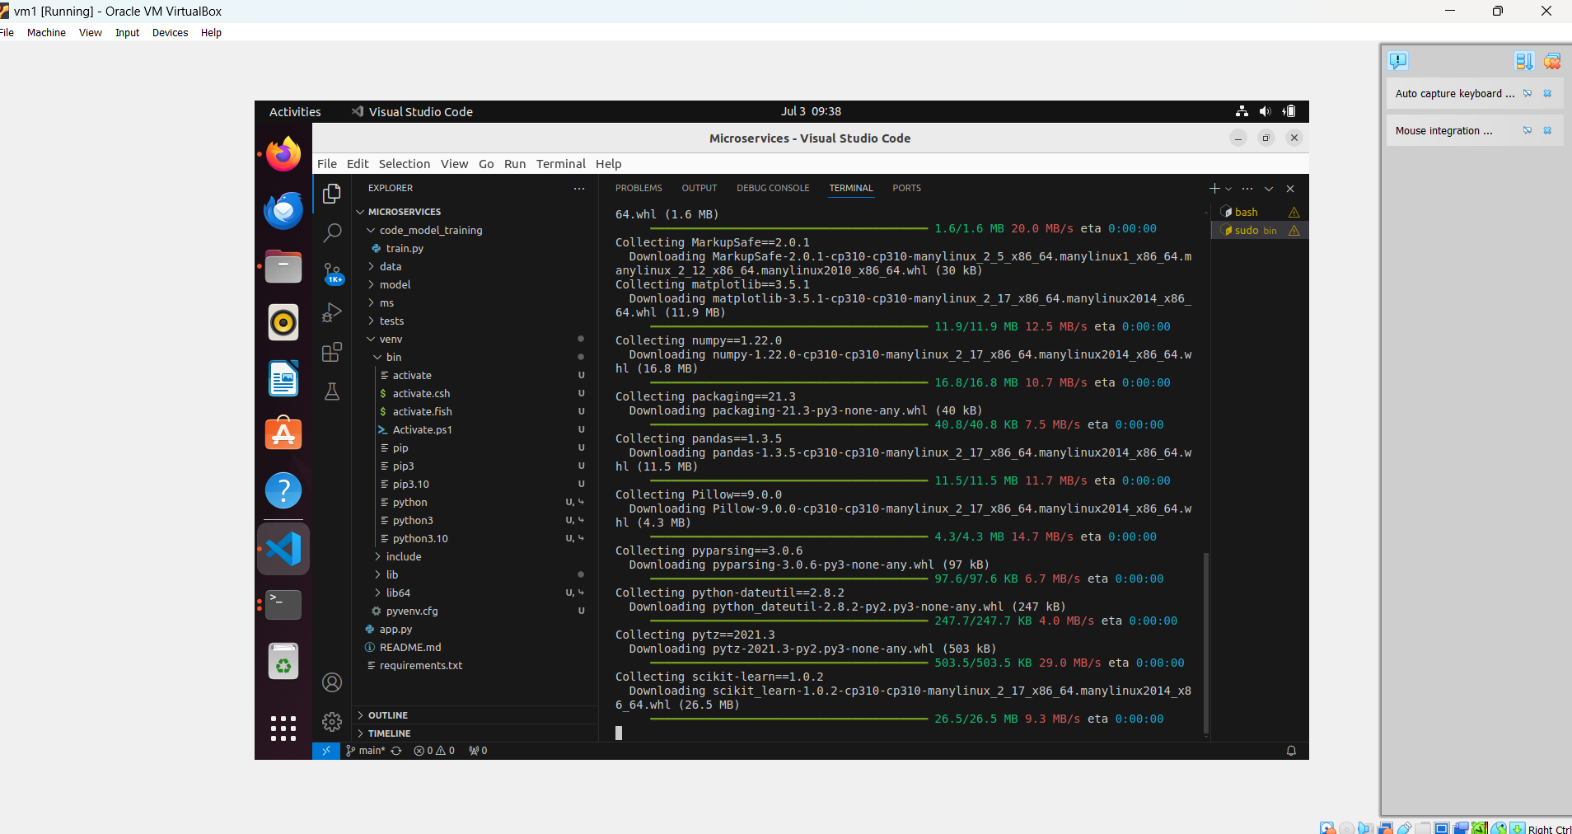

7.Train and save the model. (2 marks)

python3 code_model_training/train.py

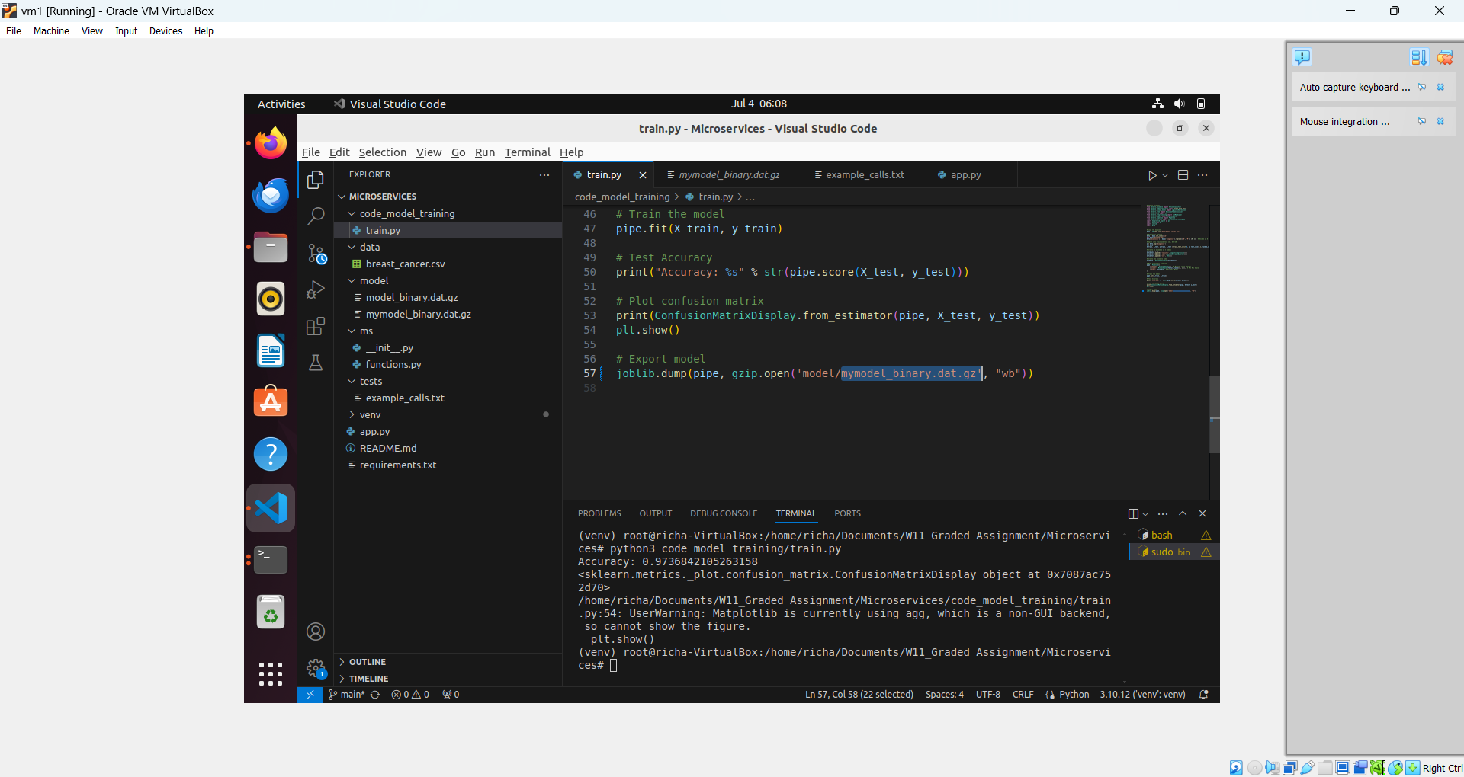

8.Test the Flask web application. (5 marks)

python3 app.py

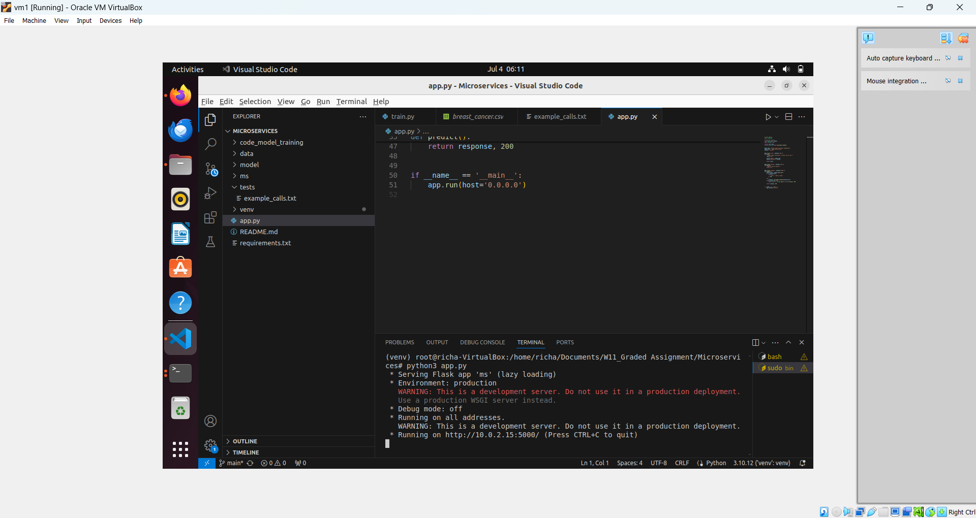

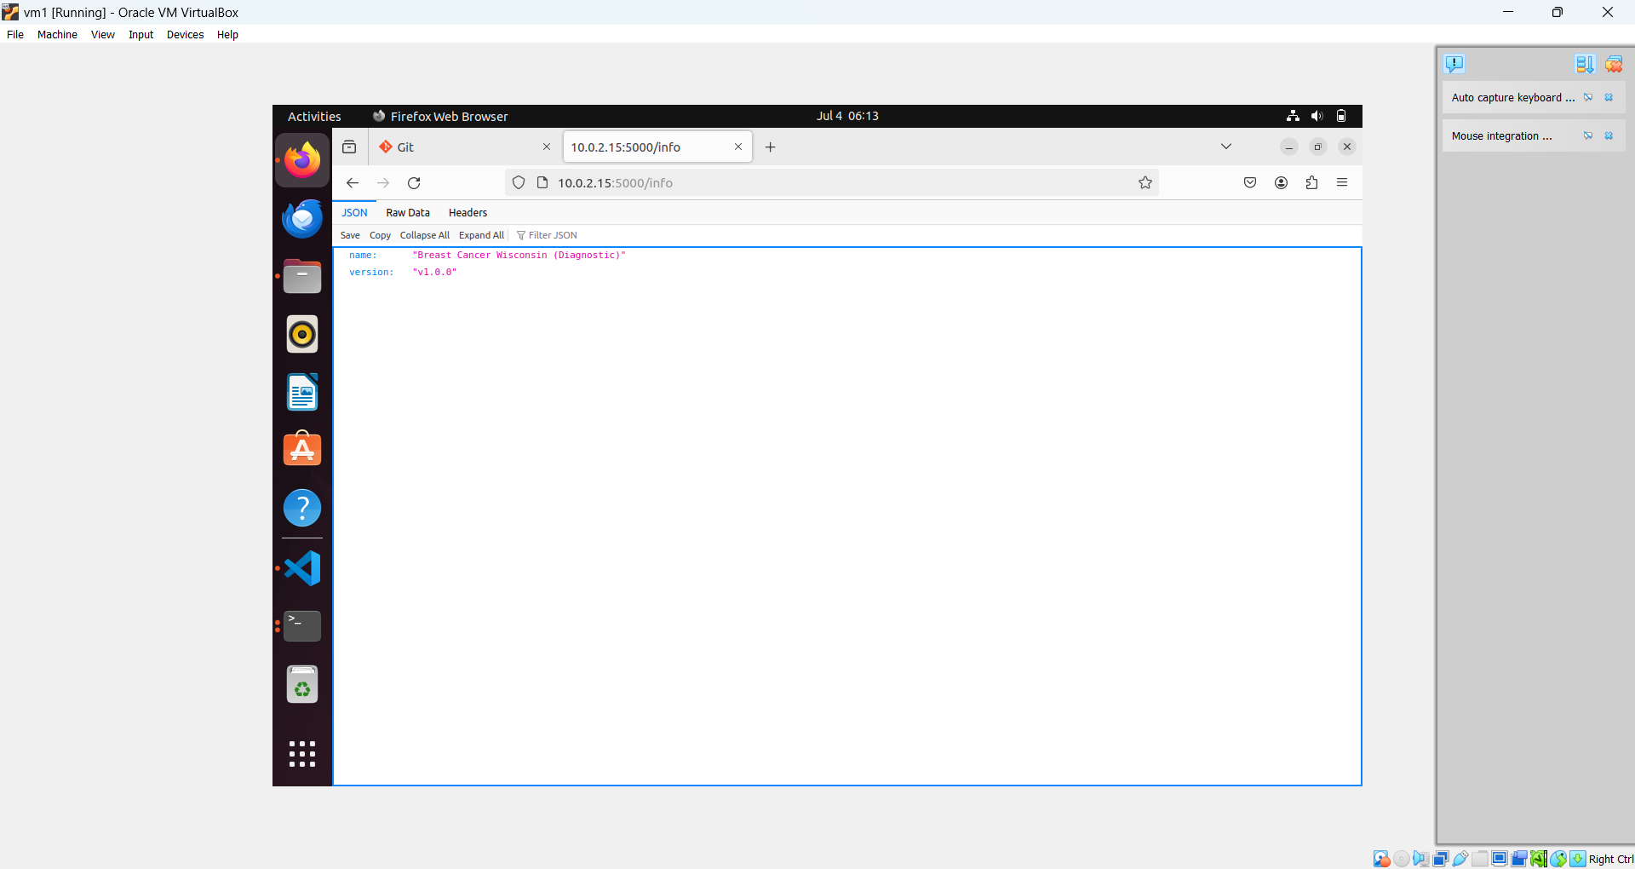

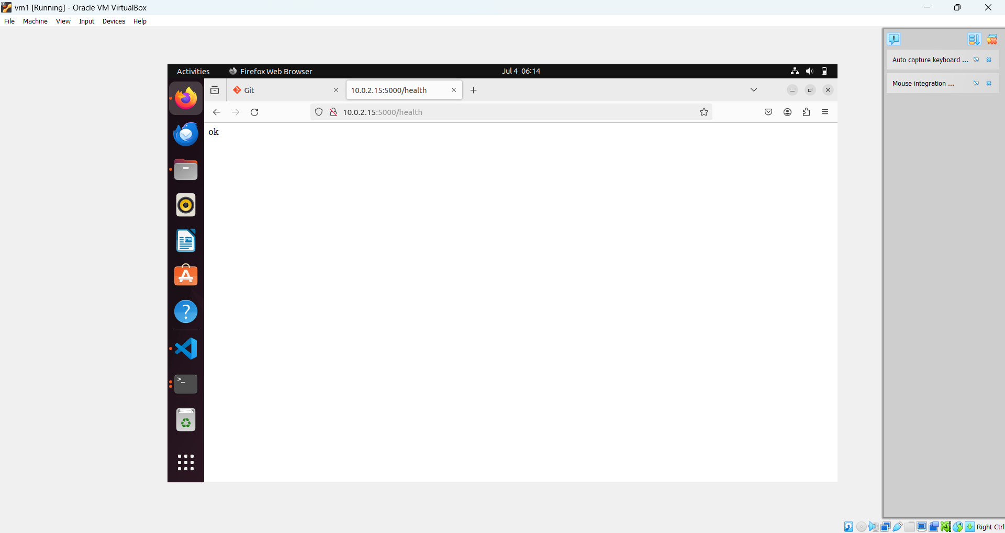

9.Test the application and make predictions using the example calls available in the folder/tests.(5 marks)

sudo apt install curl

run curl commands

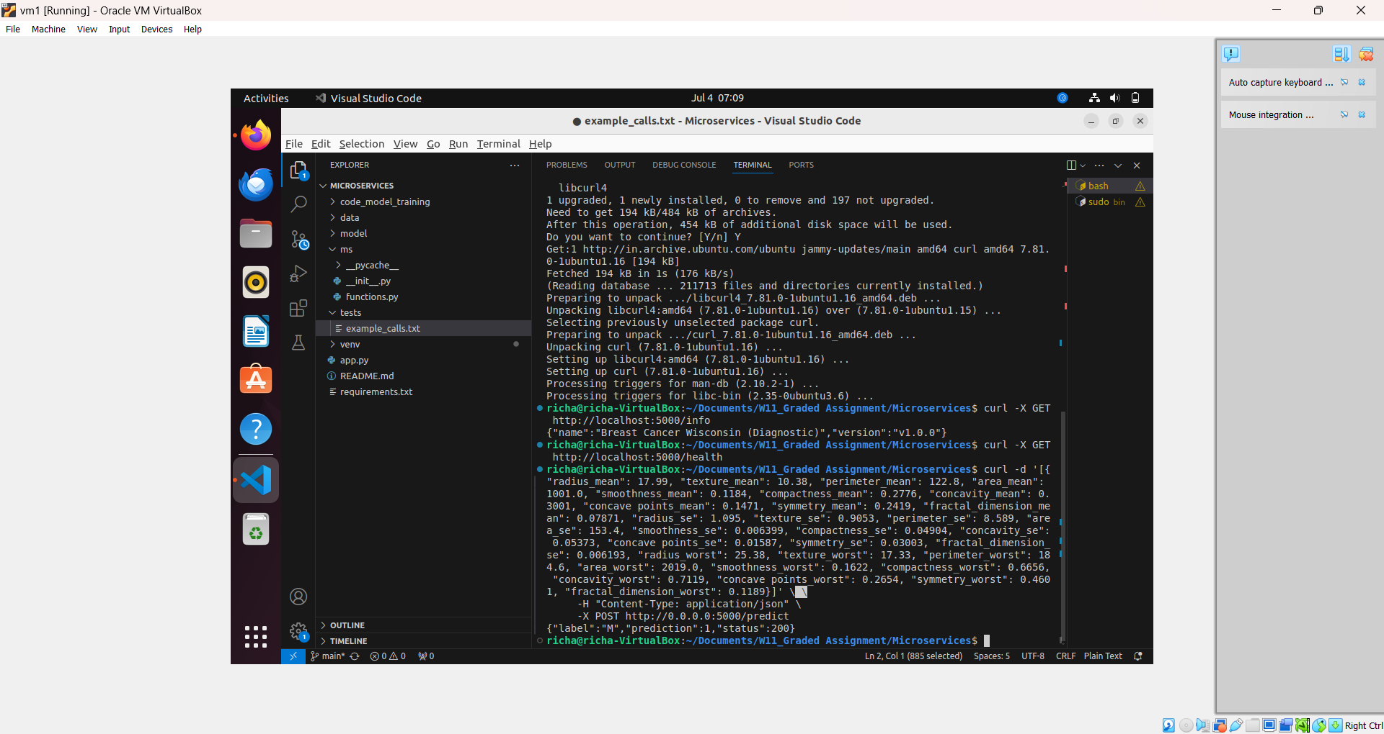

10.Create a docker image containing everything needed to run the application.(10 marks)

sudo apt install docker.io

created docker image

push it docker hub

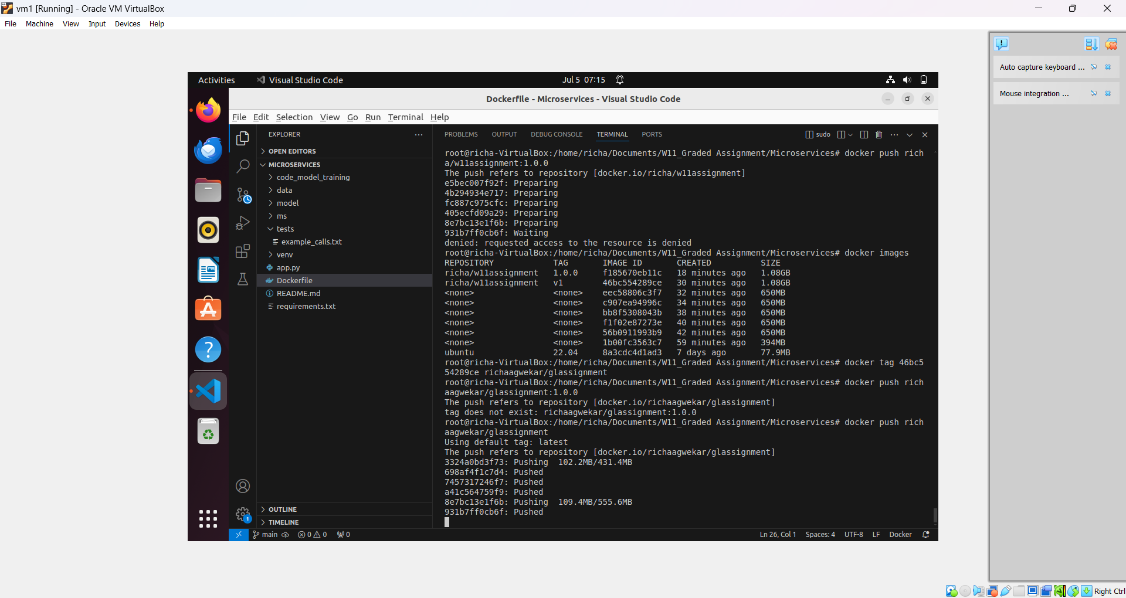

Pushed into private docker hub

Git hub : [GitHub - RichaAgwekar/RichaAgwekar-W11_Graded-Assignment](https://github.com/RichaAgwekar/RichaAgwekar-W11_Graded-Assignment)

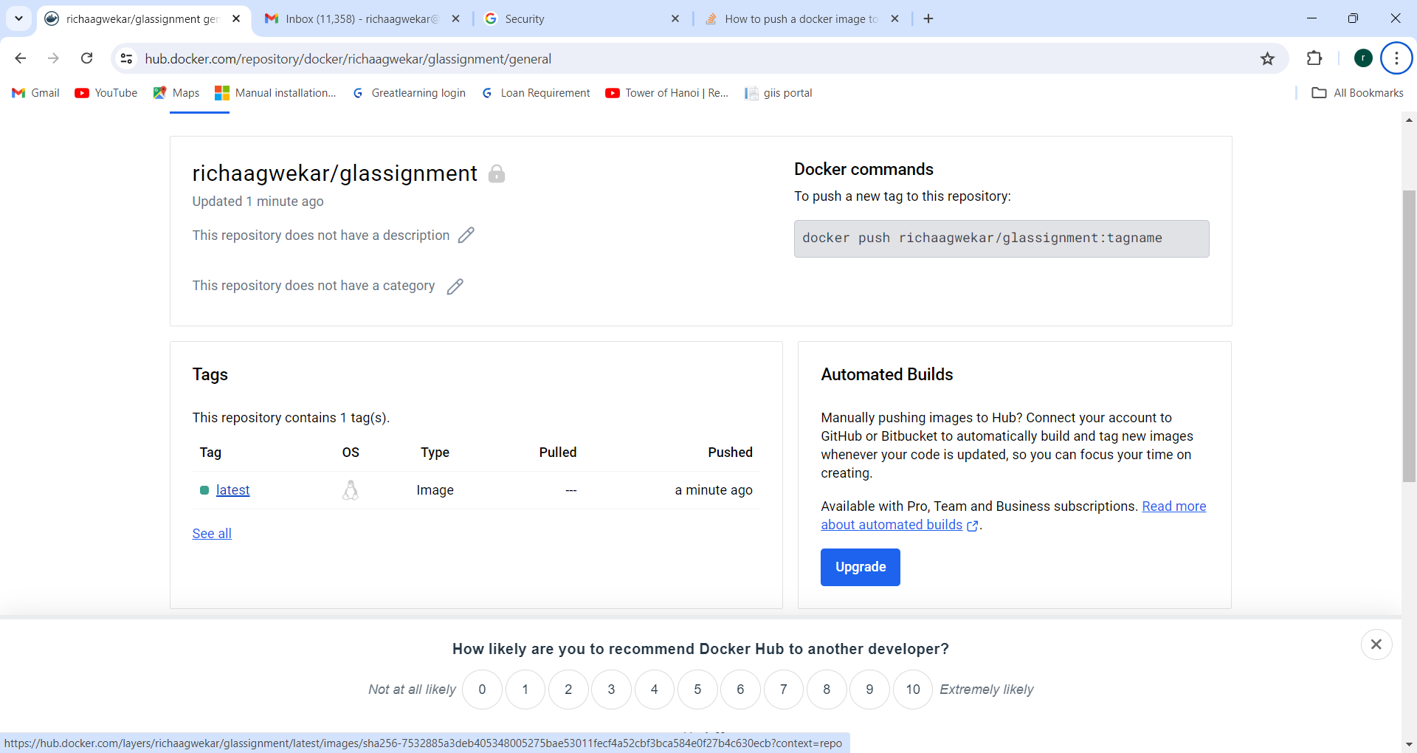

11.Run the containerized application as a prediction service and test it locally by passingsome example calls and get the prediction. (10 marks)

Pulling image locally

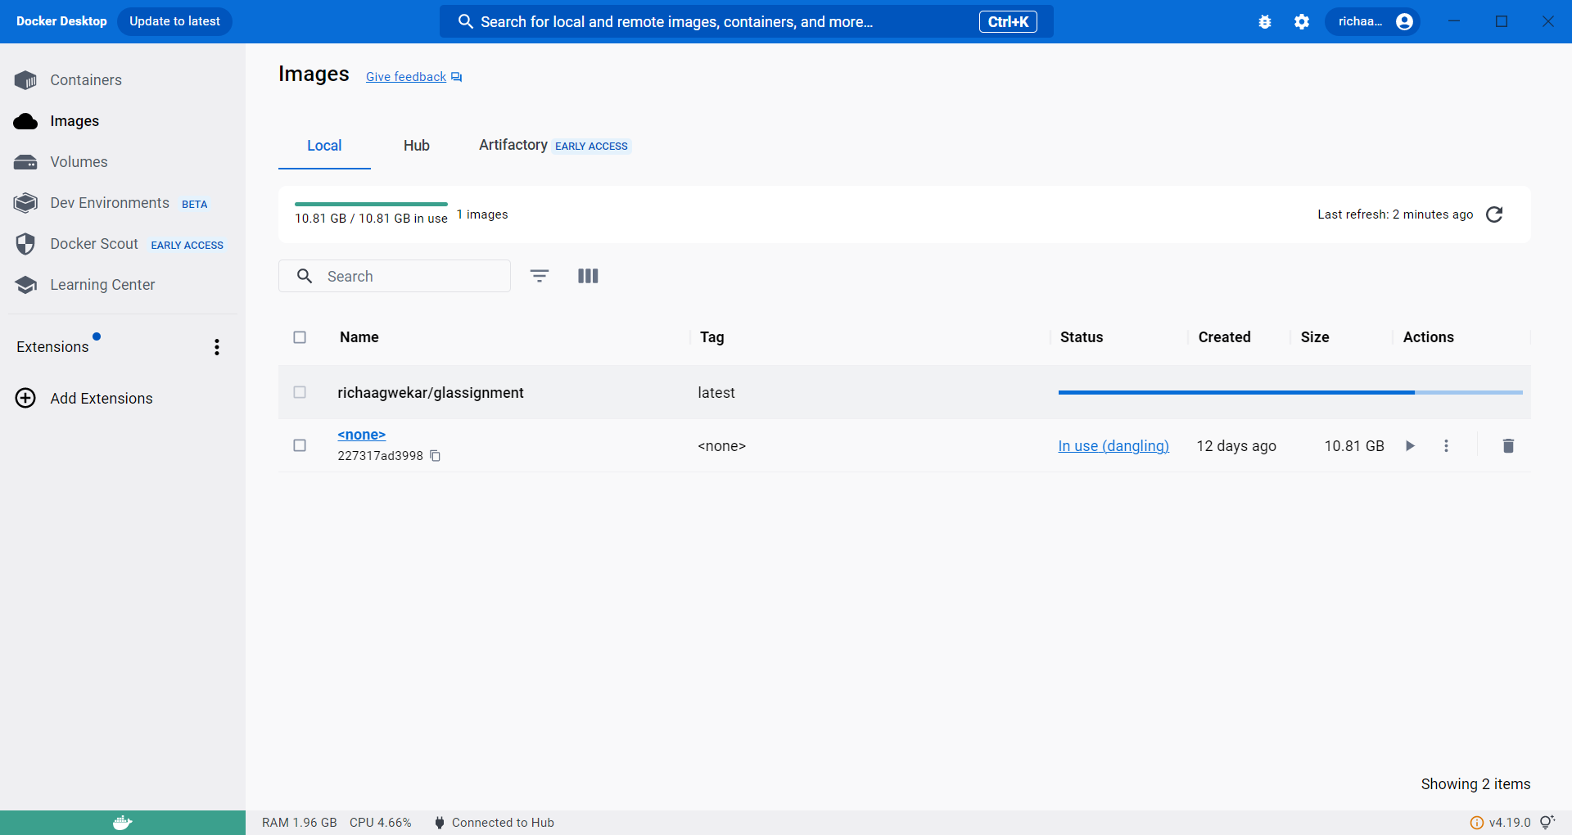

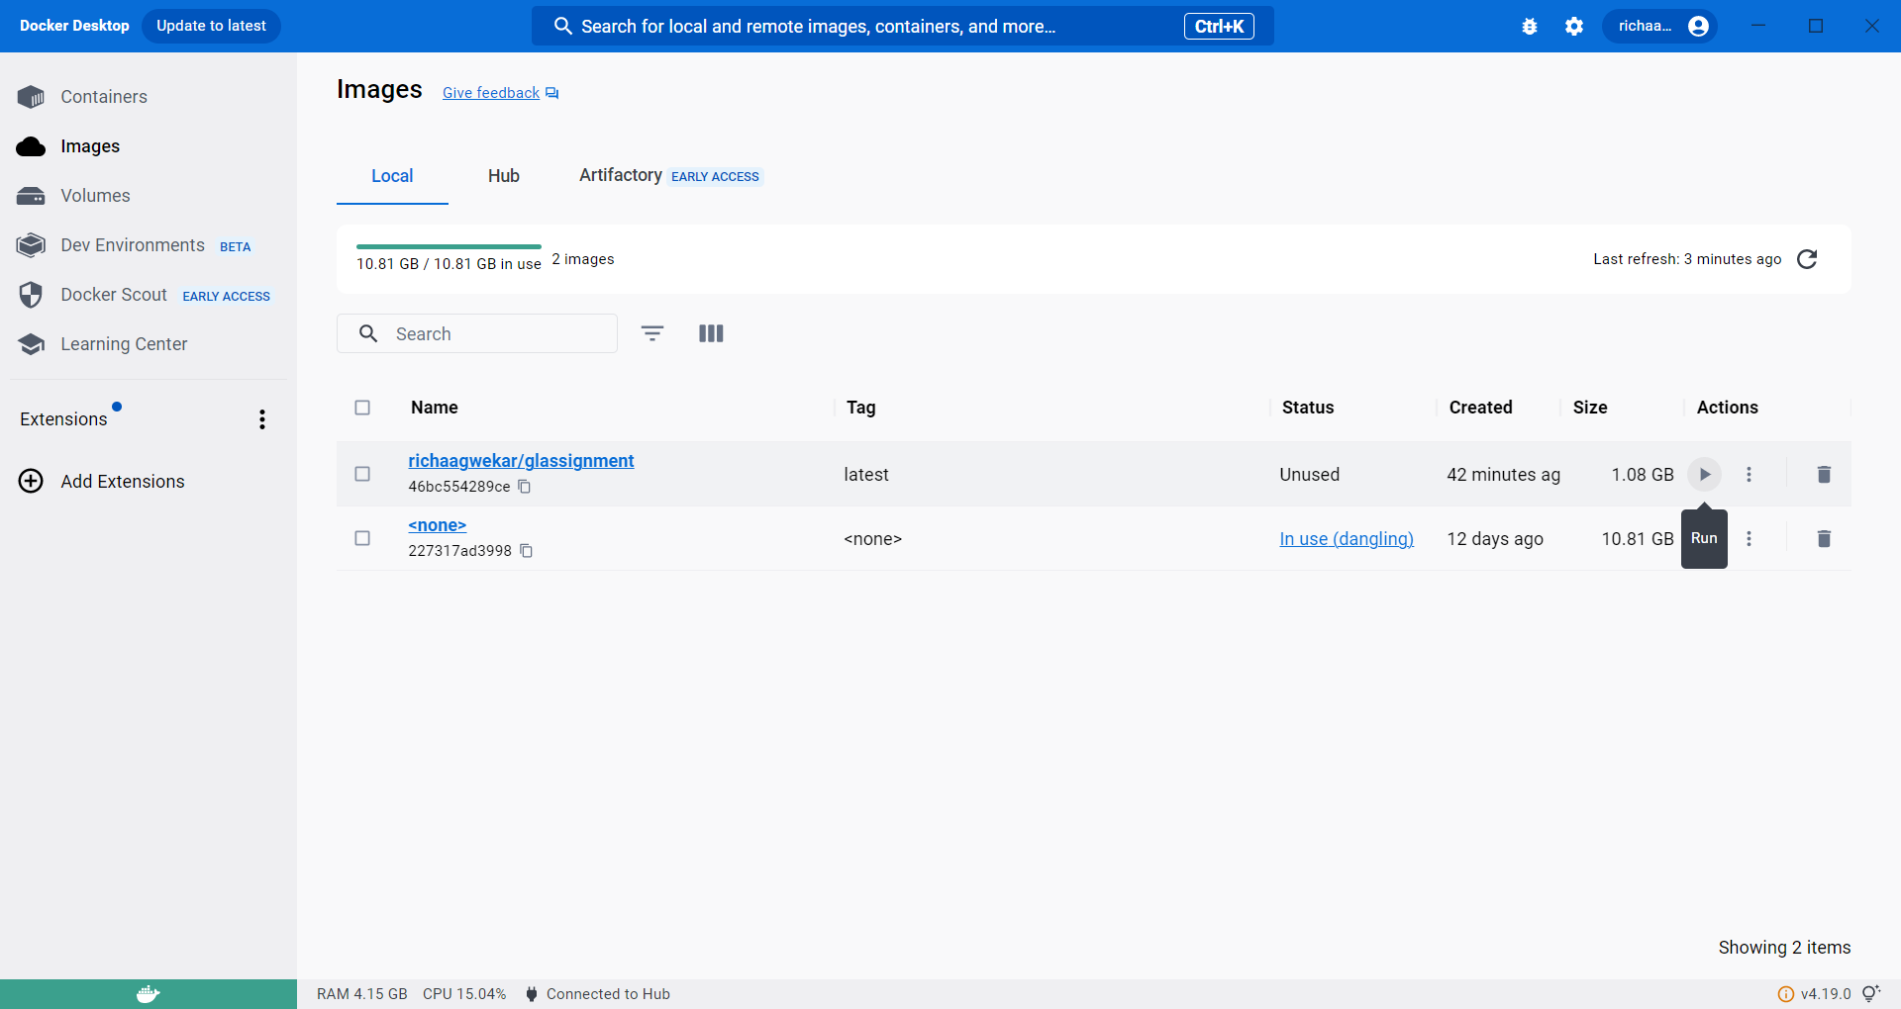

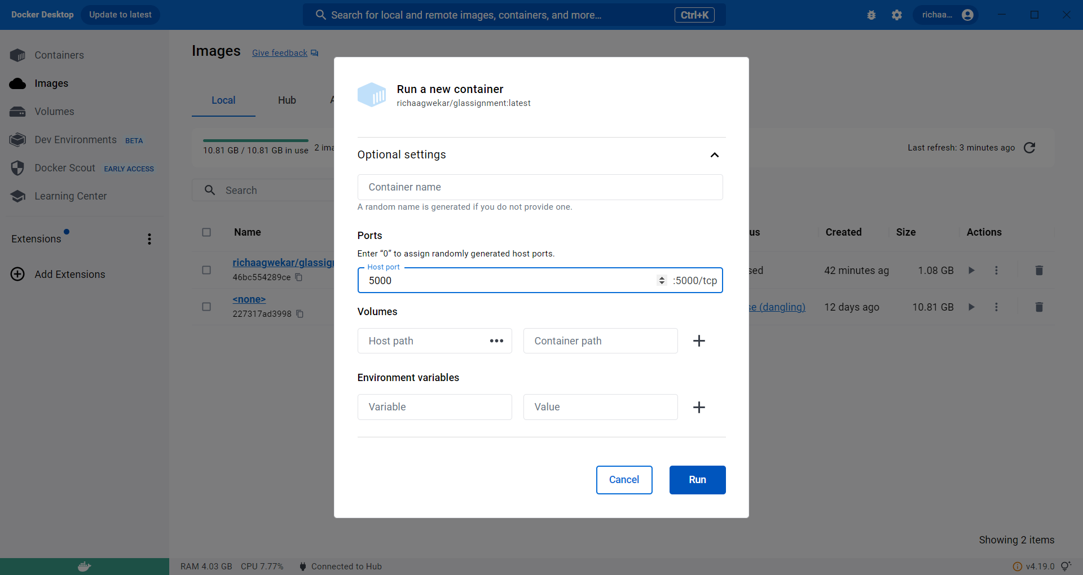

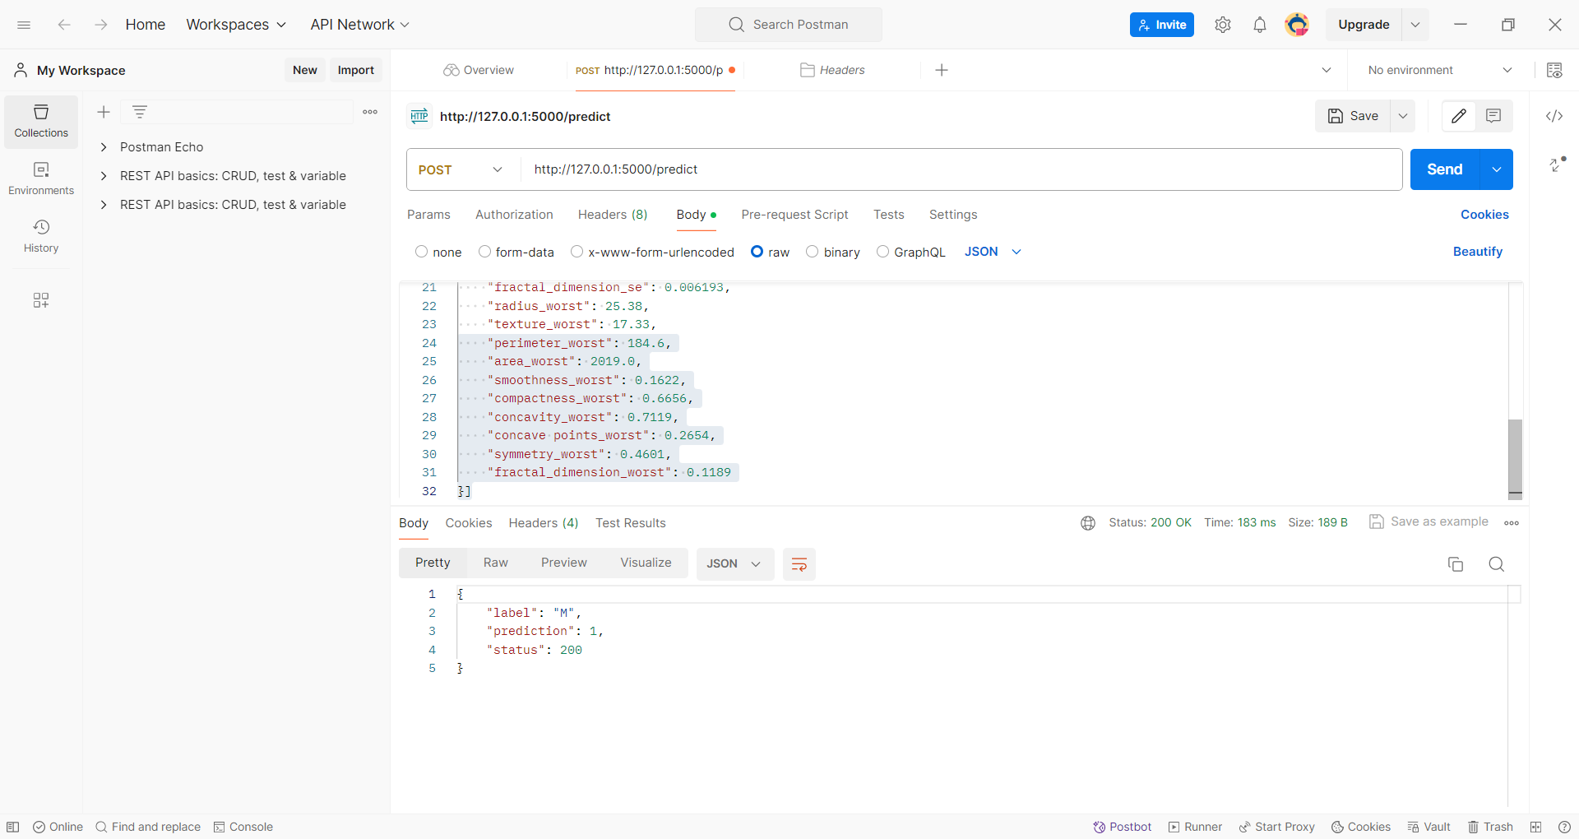

[{

"radius_mean":13.54,

"texture_mean": 14.36,

"perimeter_mean": 87.46,

"area_mean": 566.3,

"smoothness_mean": 0.09779  ,

"compactness_mean": 0.08129,

"concavity_mean":0.06664,

"concave points_mean":0.04781,

"symmetry_mean":0.1885,

"fractal_dimension_mean":0.05766,

"radius_se":0.2699,

"texture_se":0.7886,

"perimeter_se":2.058,

"area_se":23.56,

"smoothness_se":0.008462,

"compactness_se":0.0146,

"concavity_se":0.02387,

"concave points_se":0.01315,

"symmetry_se":0.0198,

"fractal_dimension_se":0.0023,

"radius_worst":15.11,

"texture_worst":19.26,

"perimeter_worst":99.7,

"area_worst":711.2,

"smoothness_worst": 0.144,

"compactness_worst":0.1773,

"concavity_worst":0.239,

"concave points_worst": 0.1288,

"symmetry_worst":0.2977,

"fractal_dimension_worst":0.07259

}]

